**Grafana ReadMe - Ralph M. Cullom**

In order to run Grafana with the dashboard we created you need a few things:

* InfluxDB bucket with your data (you need the exact name of this bucket)
* InfluxDB token
* Port number OR InfluxDB site URL
  + Use port number if using actual device, URL if using test data via InfluxDB Cloud
* JSON file (basically a .txt) which has our code for the dashboard

Once you have those three it is very simple and straightforward.

1. Load Grafana Cloud and create an account.
2. Once you’ve signed in go to Home > Connections > Data Sources
3. Select Add a New Data Source
4. Select InfluxDB
5. You can name the source whatever you want it to be.
6. Change the Query Language to Flux.

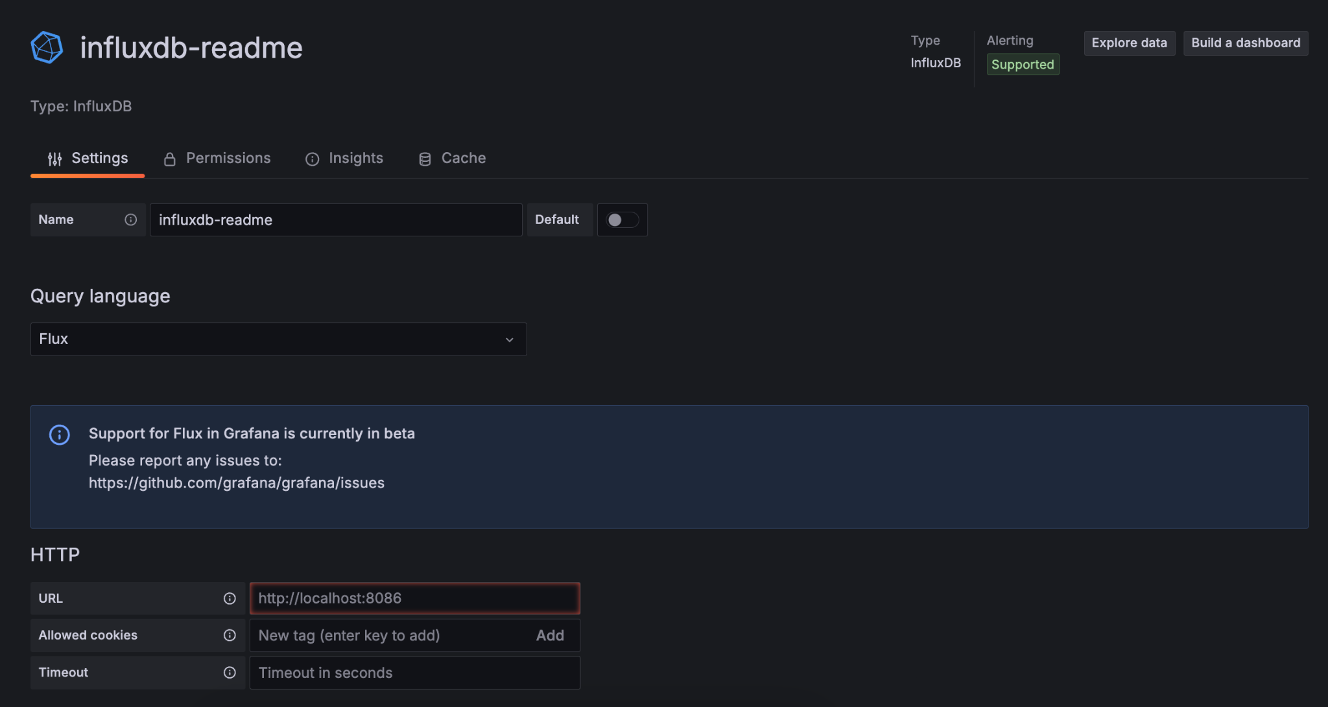

It should look like this!

1. Under HTTP at the URL section if you’re using the device put:
   * 1. Keep the localhost URL just make sure the port is correct.
   1. If you’re using the Cloud version of influx
      1. Copy/Paste the URL from InfluxDB, when testing for our project I used https://us-east-1-1.aws.cloud2.influxdata.com
2. Scroll down and change the organization to match your InfluxDB organization.



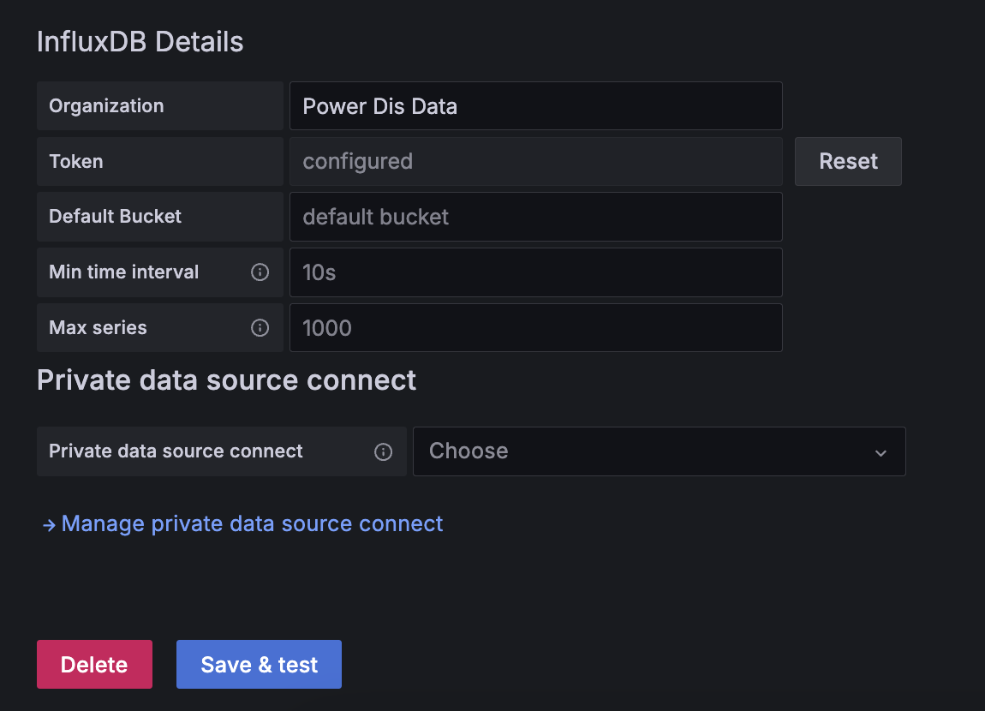

1. After that just select Save & Test and it should be able to see the buckets in InfluxDB.
2. Now all that’s left is to import the Dashboard.
3. On the left side of the screen tap on the 3 lined icon (this expands some of the items on the side panel). Select Dashboards.
4. On the top left of the screen select New > Import. Then just copy and paste the JSON file from the Grafana folder appropriate for your version (there’s one for Cloud and one for our actual device) and the dashboard is finished and you can view the graphs.